ITtoolkit Article Collection
- Home

- Articles Directory

- Current Article

How to Create Actionable Agendas for Productive Meetings

Question: What’s the difference between a meeting that just takes up time and a meeting that makes good use of time? Answer: An actionable agenda that is simultaneously relevant, realistic, organized and tangible. Actionable agendas don't just "happen" - you have to make them happen - using strategic thinking, proactive planning and consistent standards. Read on to learn how it's done.

Getting Started: A Template for Productivity
Labels aside, what makes a meeting “productive”? To be called productive, a meeting must be necessary, it must serve a purpose, it must deliver a result, and it must be an effective use of everyone's time.
On the flip side, what makes a meeting less than productive? Non productive meetings are generally those that either fail to produce a meaningful result, or take more time than should be necessary considering the results produced. Further, non-productive meetings are often characterized by conflict, confusion, lack of preparation, and a lack of participant engagement. In other words, non productive meetings are something to avoid. And, since meetings are a fact of life – why not make them as productive as possible? Obviously, we all want that, but as always, productivity comes at a price. You must be willing and able to invest appropriate time, effort and energy into pre-meeting planning and agenda development. The key is to find a simple way to achieve meeting productivity with minimal “pre-meeting” overhead. And, at the end of the day, this process begins and ends with the meeting agenda (how it is developed, produced and then executed).
As can be expected, the best way to ensure “actionable agendas” and productive meetings is to employ a standardized process for meeting planning and agenda development – one that breaks the effort down into “building blocks” that can be readily adapted and applied. In short, this process boils down to the following steps:

Set appropriate goals for meeting planning and related results.
Identify meeting requirements by defining meeting scope and purpose.
Translate identified requirements into actionable agenda items.
Organize the established agenda items into an executable meeting structure that can be carried out in a pre-defined amount of time.
This process is detailed further below, starting with some basic planning definitions.

What Makes An Agenda Actionable?
Before that question can be answered, you must step back and ask “what is a meeting agenda”? At the broadest level, meeting agendas are roadmaps for how meetings will be conducted. Agendas establish the topics to be covered and issues to be addressed, organized into a logical sequence, suited for discussion and/or presentation, and carried out in a set period of time.

So what makes an agenda actionable? To be considered truly actionable (capable of achieving pre-planned objectives with minimal overhead burdens), meeting agendas must be purpose driven, reality based and results oriented, as defined by the following four (4) characteristics:
- Relevant: The agenda must be sufficiently relevant to and aligned with the established meeting purpose For example, if the purpose of the meeting is to make one or more decisions, the agenda must be crafted to ensure that all required information is conveyed and that appropriate discussion can take place.
- Realistic: The agenda must be achievable, considering the meeting purpose, time available, participants and overall project status. For example, it is neither productive or actionable to plan a 3 hour agenda when only 1 hour is available.
- Organized: The agenda must be properly organized to meet designated objectives, present required information, and conduct related discussions in a logical, orderly fashion - one that makes sense and provides clarity. Agendas must also be properly structured considering the time available for the meeting and the time required to realize desired meeting goals.
- Tangible: The meeting agenda must be produced in a tangible, useable format, for distribution to all participants in advance of the scheduled meeting date.

So, as agendas are planned, you can ask (4) simple questions:

Does this agenda suit the meeting purpose?
Does the agenda make sense and is it do-able?
Is the agenda properly organized (considering both purpose and constraints)?
Is the agenda properly documented, detailed and ready for distribution?
If these questions can be answered in the affirmative, you have the makings of an actionable agenda, ready for a productive meeting.

Creating the Actionable Agenda
It takes two types of “templates” to prepare an actionable meeting agenda. One is the “physical kind”, used to document agenda (the agenda deliverable) and the other is the “logical kind”, providing a “plug and play” process for agenda development.
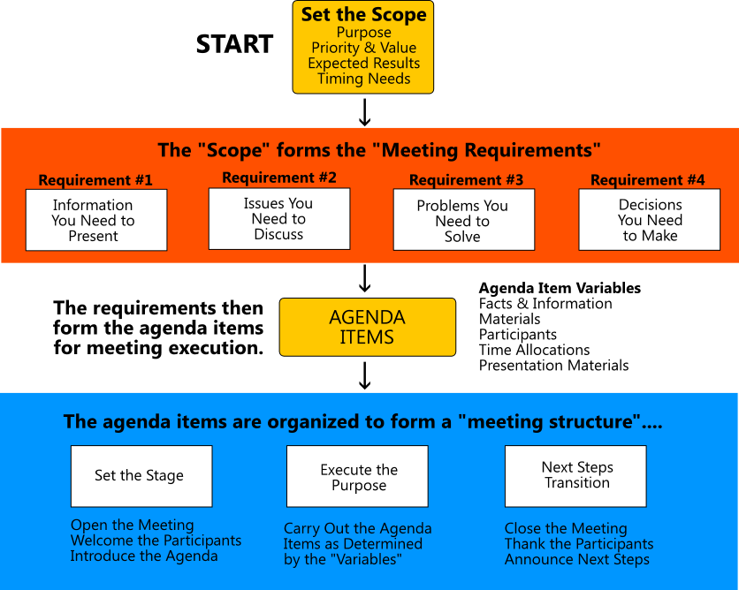

Executing the Steps (As Shown Above)
Step 1: Identify Meeting Scope. Agenda "assembly" begins with an analysis of meeting scope, to clearly identify meeting purpose (what will be accomplished), priority and value (considering overall importance and urgency), planned results (expected outcome of the meeting) and timing needs (when the meeting will take place and amount of time available).
Step 2: Scope Forms Meeting Requirements. Scope is then broken down into manageable " meeting requirements", covering the various types of information to be presented, issues to be discussed, problems waiting to be solved, and decisions that must be made.
Step 3: Meeting Requirements Form Agenda Items. These requirements are then translated into individual agenda items, to be ordered in sequence as they will be addressed at the meeting. Individual agenda items become actionable when they are sufficiently detailed considering subject matter facts, materials to be used, the participants involved (including those involved in presenting), and related preparation requirements (for meeting attendees).
Step 4: Agenda Items Are Organized for Action. Every meeting is structured into three (3) primary phases as follows: to set the stage (welcome everyone and set expectations), execute the purpose (carry out the agenda items) and transition to next steps (close the meeting). While the specifics of each phase will vary, this approach ensures that every meeting is planned and executed in a consistent manner, covering all of the required bases. Each “phase” is populated with agenda items, ordered into a logical sequence, and made timebound, all to ensure that the meeting is executed in an orderly fashion. And, each phase is then documented for distribution and use as a formal Meeting Agenda.

Whether you need to “meet” for planning, brainstorming, decision making or presentation purposes, one thing is clear – you need an actionable agenda that is suitably relevant, realistic, organized and tangible. And you need a way to create each and every agenda that saves time and produces consistent results. That’s the best way to achieve meeting productivity – to maximize time spent and minimize time wasted.

